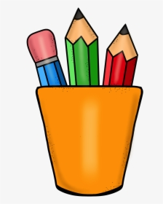
Pre-K Supply
List

- 1 Box of 24 pack Crayola Crayons
- 1 Pair of (kid friendly) scissors
- 1 Pack of pencils
- 1 Pack of glue sticks
- 1 Composition notebook
- 1 pencil box
- Erasers
- 2 boxes of tissue
- 1 Plastic 3-pronged folder
- Hand sanitizer

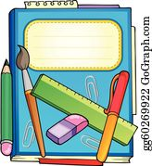

Teacher Wish
List

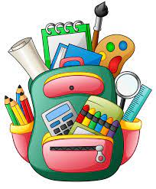
- Band-Aids
- Disinfecting wipes
- Baby wipes
- Computer printer paper
- Paper Towels
- Sanitizing spray

